**Enterprise Application Development**

**Tutorial**

**Introduction to Git**

**SLIIT-2015**

**Background Details**

SourceTree is a powerful Git and Mercurial desktop client for developers on Mac or Windows. This tutorial uses SourceTree to interact with a Git repository created in Github.

**Cloning from GitHub**

Let's clone the repository on Github

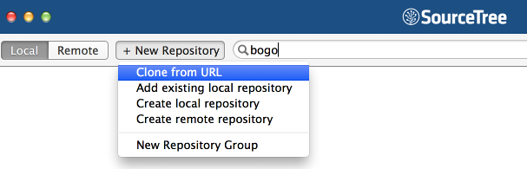

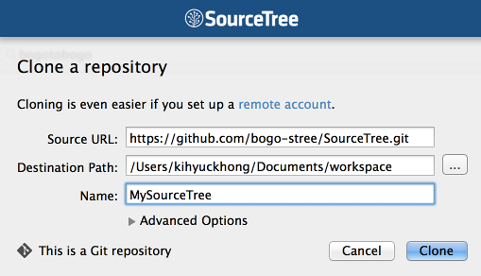

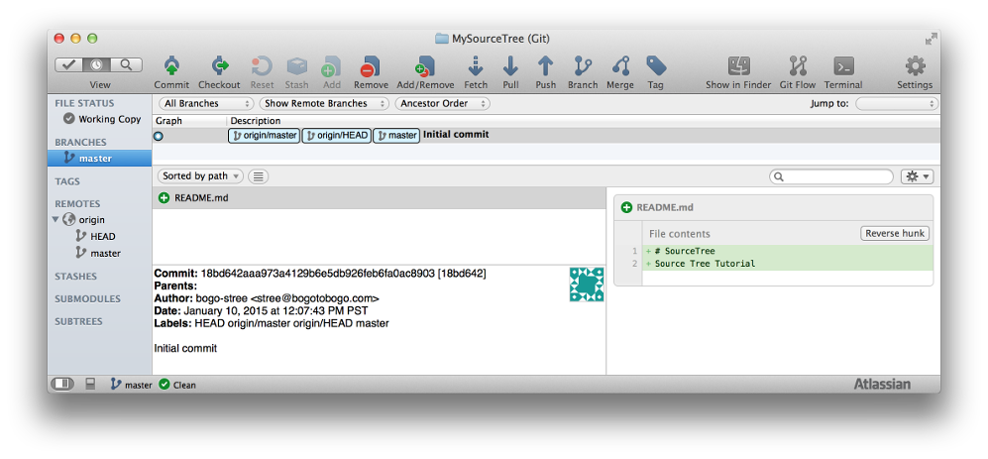

**Staged & Unstaged**

If we make a new file on our local machine, we'll have "Uncommited" changes:

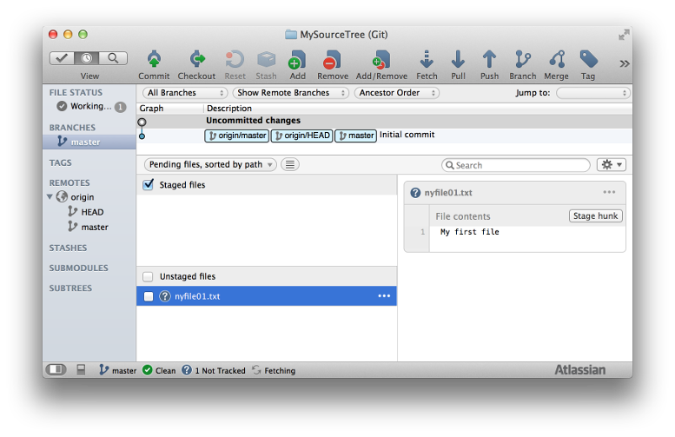

We can put the file into staging either by checking "Unstaged files" or the text box next to that file:

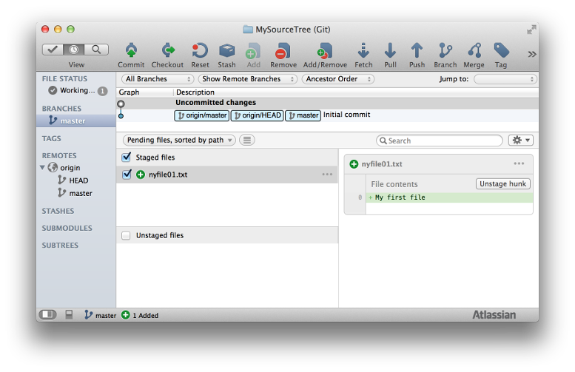

**Commit to the Local Repository**

Now commit the file in the staging area. Fill in out comment, and the hit "Commit" button:

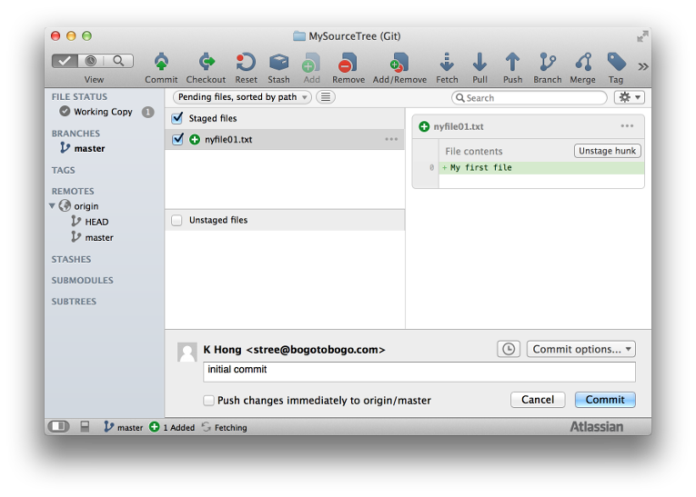

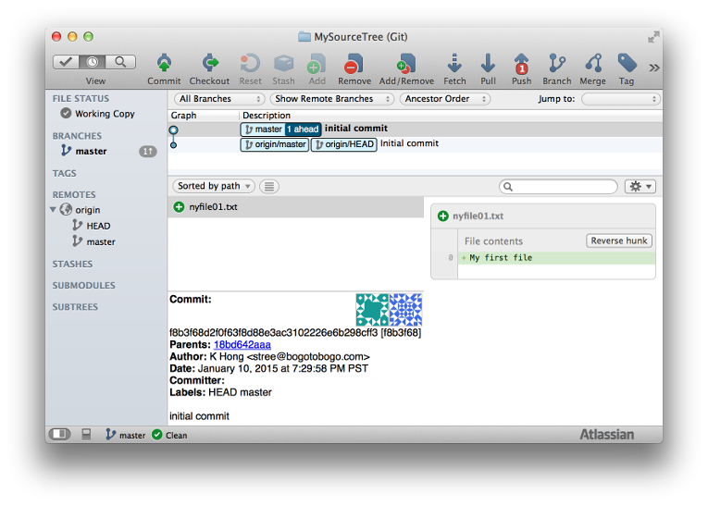

Now, we can see our local repository is 1 ahead of remote repository (origin/master)

**Pushing to GitHub**

Before we do Push, we need to Pull first, so hit the Pull on the top menu:

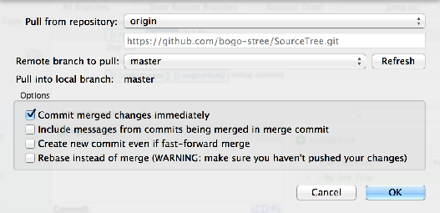

Now, press "Push" on the top menu:

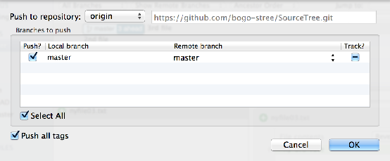

As shown below, now our local and remote repositories are in sync.

